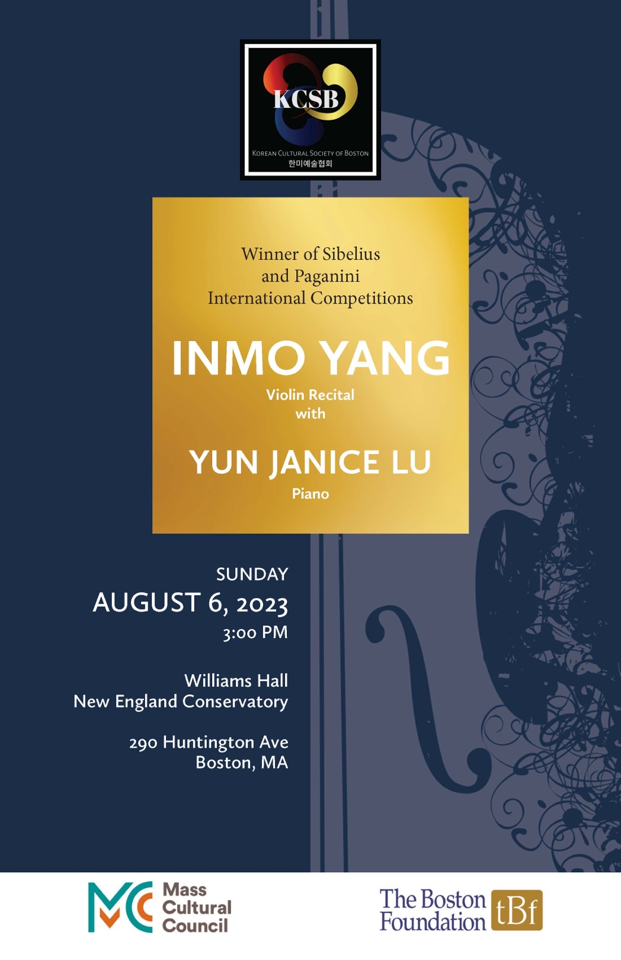

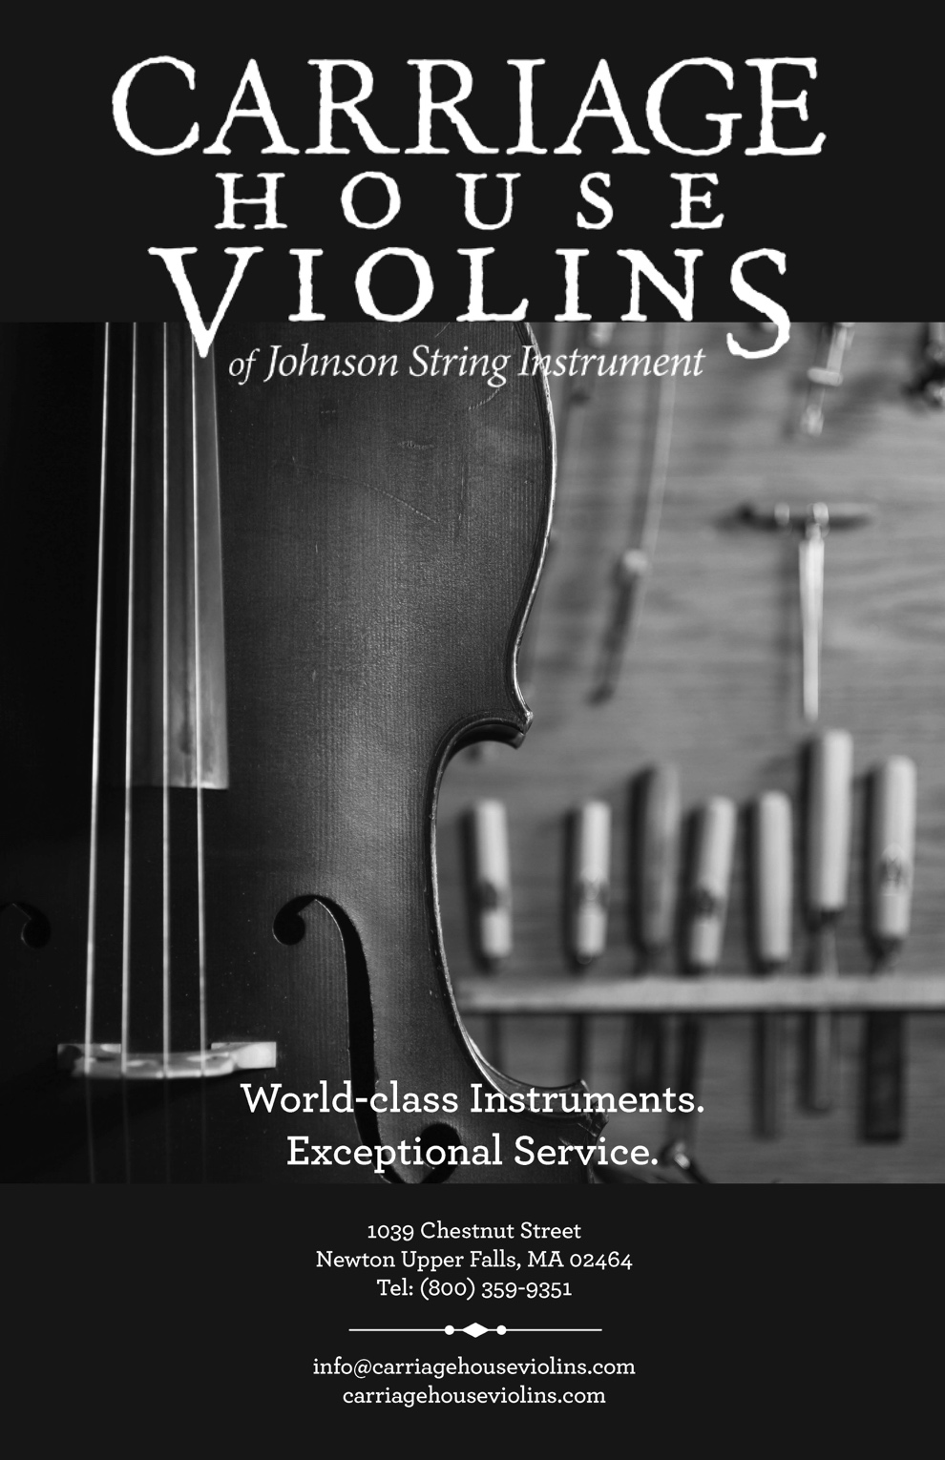

Inmo Yang, violin
Yun Janice Lu, piano

Sunday, August 6, 3pm
New England Conservatory
Williams Hall

Sonata for Violin and Piano in G minor Claude Debussy
(1862–1918)
Allegro vivo
Intermède: Fantasque et léger
Finale: Très animé

Violin Sonata Leoš Janáček
(1854-1928)
Con moto
Ballada
Allegretto
Adagio

- Intermission -

Sonata in A major for Violin and Piano César Franck
(1822–1890)
Allegretto ben moderato
Allegro
Ben moderato: Recitativo-Fantasia
Allegretto poco mosso

PROGRAM NOTES
Sonata for Violin and Piano in G minor (1917) – Claude Debussy
The Sonata for Violin and Piano in G minor was one of Debussy’s final compositions, which he premiered with violinist Gaston Poulet a year before his death. It was the third and final piece of a larger sonata cycle intended to contain six works, but the project remained incomplete due to his death. Written amid World War I while his health was declining, Debussy said of the piece, “This sonata will be interesting from a documentary point of view as an example of what may be produced by a sick man in time of war” (Scott Foglesong, 2019). The sonata is surprisingly brief, lasting just around 13 minutes, yet it explodes with a full range of timbral colors and harmonies signature to Debussy’s compositional style.
The first movement, Allegro vivo, begins with two solitary chords in the piano—g minor and C major—laying the foundation on top of which the violin enters with a descending melodic figure. The g minor to C major progression recurs throughout the movement, and it foreshadows the frequent harmonic shifts between major and minor. After the contemplative opening, the pace of the movement surges forward, propelled by a descending, staccato arpeggiated figure in the violin. The middle section of the movement unexpectedly shifts to E major and features an arpeggiated, rolling triplet piano line that creates tension against the violin’s duplets. After restating the first theme, the violin pushes forward in chromatic ascending and descending lines, eventually joined by the piano, which gives way to a grandiose ending to the movement.
The second and third movements are emblematic of Debussy’s late style, which is characterized by his use of motivic fragmentation and juxtaposition (Marianne Wheeldon, 2004). Intermède: Fantasque et léger interweaves and alternates between “whimsical,” expressive legato lines and mischievous, staccato scherzo-like melodies. Finale: très animé, meanwhile, takes fragmentation and juxtaposition even further, sequencing through many motives and colors. The finale begins with a restatement of the main theme from the first movement, but the piano accompaniment this time is much more active and animated. The violin joins in to match this energy with a melismatic, virtuosic melody. After a buildup of dissonance through harmonic sequencing, there is a gradual slowing of both tempo and harmonic pacing that leads to a brief, languid, expressive section. The movement then picks up in pace again, with the piano playing a descending line in its left hand that seems reminiscent of joyous bells, concluding the piece with two massive chords.

Violin Sonata (1914) – Leoš Janáček
Like Debussy, Janáček had written the Violin Sonata with World War I raging in the background. He has said of the sonata, “in the 1914 Sonata for violin and piano I could just about hear sound of the steel clashing in my troubled head” (Gary Lemco, 2022). Yet, Janáček was also hopeful that the war, and especially Russian forces, would liberate Czechoslovakia from Austro-Hungarian rule. The sonata underwent several revisions and would not be finalized until 1922, four years after the war had ended.
Con moto begins with a passionate violin melody under which the piano plays a repeating tremolo figure. This tremolo sets the tone for a sense of anxiety and urgency throughout the entire movement, which prevails despite occasional moments of sparser quiet. Similar to Debussy’s later style, Janáček relies upon smaller motivic fragments to construct the piece, but he alters and elaborates on them to perhaps an even greater extent. Ballada was originally composed as a separate piece in 1914, but Janáček incorporated it into the sonata as its second movement. It features long, singing melodies in the violin with a shimmery piano accompaniment underneath. The harmonies range from warm, open, and simple to more dense and unexpected shifts, which seem to nod towards Debussy’s impressionist harmonic language. The second theme picks up in tempo and is characterized by a rhythmic figure of three short, repeated notes followed by a long note. The final bars of the movement are delicate and shift between major and minor, before ending gently in the minor.
Allegretto is a short, quasi-scherzo movement that most clearly foregrounds the folk-influence Janáček derived from his native Moravian music. The piano begins with a folk-like melody, which is interrupted by descending flourishes in the violin, and ending with three punctuated, unison chords. After a slow, more lyrical middle section whose rhythm and lyricism hearken back to the second theme of the Ballada, the movement ends with the initial melody and its three punctuated chords. Finally, the Adagio begins with a sweeping, legato piano melody that is once again interrupted by a fast, rhythmic figure in the violin. As this juxtaposition continues, the two instruments eventually come together in the sweet, singing middle section. Towards the end of the movement, the violin takes over the melody while a tremolo figure appears in the piano accompaniment—recalling the first movement’s opening—before the two switch roles. The piece concludes with a coda, which offers a final restatement of the piano’s initial theme and the violin’s interrupting figure, though both have lost their initial energy and fade into silence.

Sonata in A Major for Violin and Piano (1886) – César Franck
Franck’s violin sonata is widely considered to be a staple within violin and chamber music repertoire, and it was presented as a wedding gift to violinist Eugène Ysaÿe in 1886. The piece puts on full display Franck’s use of cyclic form, where the recurrence of thematic and melodic material throughout the four movements provides cohesion to the sonata’s overall form.
Allegretto ben moderato begins with the piano outlining two lilting chords, setting the mood for the violin’s entrance, whose melody seems to pose listeners with a question. The second theme is strictly in the piano, and it picks up in tempo and expressivity as it cascades downward. Colorful harmonic shifts transform the recurring motives, and in the middle section, the violin and piano exchange the first theme back and forth until its questioning quality is finally resolved at the end of the movement. The Allegro, meanwhile, is tumultuous and full of angst. Here, the violin begins in the lower-middle part of its register, and this, along with the syncopated rhythm of its melody, adds to the denser texture and mood of the movement. After a slower, more lyrical section where the violin finally rises above the piano, the pace picks up and returns to the animated and tumultuous energy from the beginning of the movement.
Ben moderato: Recitativo-Fantasia begins with the piano playing a figure reminiscent of the first movement’s primary theme, followed by the violin playing a quasi-improvisatory line marked “con fantasia.” The two instruments then exchange fragments of the first movement’s themes. Franck then introduces a new, dramatic second theme in the violin, characterized by large intervallic jumps. He continues to weave in fragments of motives from the prior two movements, which range from dreamlike to dramatic and rhapsodic. Finally, the Allegretto poco mosso is predominantly a canon between the two instruments and demonstrates Franck’s proficiency in contrapuntal writing. The melody is almost folk-like in its simplicity, imbuing it with light and graceful feel. This theme interwoven with themes from the previous three movements, providing a structural and thematic unity to the whole piece. In the final bars of the movement, the canon becomes condensed as the violin echoes the piano with just a half measure between them, launching the two instruments into a thrilling, triumphant ending.
— Annie Kim

M.A., Musicology, Tufts University
Ph.D. Student, Musicology & Ethnomusicology,
Brown University

ABOUT THE ARTISTS
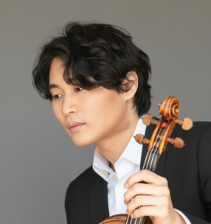
Korean violinist Inmo Yang is the first prize winner of the 2022 Jean Sibelius Violin Competition. He was also awarded a prize for the best performance of the commissioned work written by Magnus Lindberg. Sakari Oramo- the chair of the jury- commented: “The winner was overwhelming. There is so much great about Inmo’s playing, both musically and violinistically. There is never anything extra involved in changing the spring, which produces singing and ease.”
In March 2015, Inmo won the 54th International Violin Competition “Premio Paganini” in Genoa, Italy, marking the first time since 2006 that the Paganini Competition jury awarded First Prize. Fabio Luisi, the chair of the jury at the time, commented: “Inmo is an intuitive musician. His Paganini is captivating and exquisite.” He also garnered the following special prizes: youngest finalist, best performance of the contemporary original piece, performance most appreciated by the audience, and a special recital in Genoa using Paganini’s own Guarneri Del Gesu violin.
Inmo made his Carnegie Hall debut at the Weill Recital Hall as a winner of the Concert Artists Guild competition, and went on to receive invitations to the Boston Symphony Hall, the Kravis Center for the Performing Arts, the Ravinia Music Festival and the Marlboro Music Festival.
Inmo has performed with many renowned conductors such as Fabio Luisi, Neeme Järvi, Myung-whun Chung, James Gaffigan, David Robertson, Marin Alsop, and Osmo Vänskä. His concerto appearances include Helsinki Philharmonic Orchestra, Finnish Radio Symphony Orchestra, Orchestre National de France, Orchestre National de Metz, Chicago Symphony Orchestra, Lucerne Symphony Orchestra, Zurich Philharmonic Orchestra, Danish National Symphony Orchestra, Seoul Philharmonic Orchestra, and Busan Philharmonic Orchestra.
Notable engagements for the upcoming season include his London debut at the Barbican Center with the BBC Symphony orchestra/Sakari Oramo, Sibelius concerto with the Philharmonia Orchestra/Santtu-Mattias Rouvali at Mikkeli Festival, and a tour with the Hong Kong Philharmonic/Roberto Gonzales-Monjas.
In 2021, Inmo released his second Deutsche Grammophon album [The Genetics of Strings]. His debut album - 24 Caprices by N. Paganini - was recorded live as part of the Kumho Art Hall residency and released under the same label in 2019.
Inmo studied with Namyoon Kim at Korea National University of Arts, Miriam Fried at the New England Conservatory of Music in Boston, and Antje Weithaas at Hochschule für Musik “Hanns Eisler” in Berlin. He is now studying at Kronberg Academy with Antje Weithaas. Inmo is playing on a violin by G. B. Guadagnini of Turin kindly loaned by Jane Ng through J & A Beare and the Beare’s International Violin Society for The International Jean Sibelius Violin Competition. Inmo is currently based in Berlin.
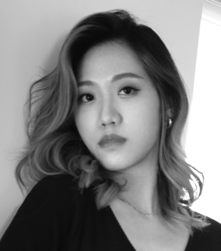
Yun Janice Lu is known as one of the leading Taiwanese pianists of her generation and is semi-finalist at the prestigious 2018 Geneva International Music Competition (Concours de Geneve) in Switzerland, winner of Chi-Mei Arts Award (2020), PianoTexas Young Artists Competition (2014), and bronze medalist at Fischoff National Chamber Music Competition (2021).
Janice has performed in all major venues and renowned festivals throughout the States, Europe, and Asia including Van Cliburn concert hall, Weiwuying recital hall, the Hahnhall, the Studio Ernest-Ansermet, Walnut Hill Music Festival, Academie Internationale d’Ete de Nice, PianoTexas Festival (formerly known as the Cliburn Institute), PianoFest in the Hamptons, and Music Academy of the West. She played her debut recital at the age of ten and gave her debut performance at the Kaohsiung Cultural Center with all Beethoven repertoires including piano concerto No.4. Her orchestral debut at age of fourteen with the Taiwan Youth Orchestra at the Chih-Te Hall garnered considerable attention of the publishers who featured her in “MuzikOnline” magazine. Remarkable orchestral collaboration includes performance with Fort Worth Symphony Orchestra under the baton of Lio Kuokman. Her performance of Liszt piano concerto No.1 brought rave reviews from critics praising that “she captured Liszt’s style,” and "took full advantage of the fireworks.”
Not only a devoted soloist, but Janice regularly engages in many chamber music performances. Collaborations with musicians include Miriam Fried, Michael Kannen, Peter Frankl, Steve Tenenbom, Ara Gregorian, Stephan Stirling, Alan Kay, and soloists from l’Orchestre de la Suisse Romande. Her recent performance marks North American premiere of Ithaka by Helena Tulve with Lucy Shelton and Anthony Marwood at Yellowbarn chamber music festival. She performs consistently at concert series, including Four Season Chamber Music Festival, Taos Chamber Music Festival, Chamber Music Evergreen in Colorado, Yellow Barn chamber music festival, Lake Champlain Chamber Music Festival, and Music@Menlo Chamber Music Festival. Janice has had the honor of working with prominent musicians such as the Brentano, Borromeo string quartets, members of the Tokyo String Quartet, Wu Han, Arie Vardi, Peter Serkin, Gilbert Kalish, among many others.
Born in 1996 in Kaohsiung, Taiwan, Janice began her piano studies at age of five. She moved to the United States to pursue studies with Ning An for four years at California State University Fullerton, and earned her both M.M (Master of Music) and M.M.A (Master of Musical Arts) degrees under the tutelage of Wei-Yi Yang at Yale School of Music as the recipient of the 2019 Elizabeth Parisot prize and the Evelyn Bonar Storrs scholarships (The Musical Club of Hartford, Inc). She currently lives in Boston and continues her studies in the highly selective D.M.A program at the New England Conservatory with Alessio Bax and Alexander Korsantia.

KOREAN CULTURAL SOCIETY OF BOSTON

Korean Cultural Society of Boston (KCSB) was founded in 2012 in order to introduce and promote Korean arts and cultural forms to a broad spectrum of New England audiences, to promote and support professional Korean-American literary, visual, and musical artists, and to enhance education of Korean culture and arts.
Board  Gillam Ahn  Insuk Jang  Haillanne Kang  Dina Kim  Ok Kyung Kim  Annie Lee  Kilza Lee  Kyungae Lim  Young Kim Shin | Sonchu Gavell  Mindy Jeon  Byung Kim  Kwang-Soo Kim  Yoo-Kyung Kim  Jaeok Lee  Kyunghae Lee  Chungpu Park  Leah Tung | Stefan Gavell  Jhung W. Jhung*  Catherine Kim  Manok Kim  Young Hwan Kim  Kang Pil Lee  Sangmi Lee  Douglas Roth
Board Emeritus  Donghee Ahn | Sekyo Nam Haines | Choong Lee
Staff  Byung Kim  President  AD Herzel  Development Director  Arts Committee  Jin Chyung  Gina Kang  Jaeok Lee*  Leah Tung | Caroline Yang  Executive Director  Liat Shapiro  Program Director  Yunhee Hong  Minhee Kim  Sangjeong Lee | Soohee Park  Treasurer  Sangmi Lee  Community Coord.  Sunhee Hur  Hyunhee Lee  Young K. Shin
Music Committee  Catherine Kim  Ji Yung Lee  Lauren Woo | Yoo-Kyung Kim  Yoo Sun Na* | Hyun-Ji Kwon  Minkyung Oh
Literature Committee
Advisory Board  Wha Kyung Byun  Jung-Ja Kim  Texu Kim  HaeSun Paik | Judith Eissenberg  Soovin Kim  YeeSun Kim  Soo Rye Yoo | Bo Youp Hwang  Sunglim Kim  David McCann

*Board or committee chairperson

Korean Cultural Society of Boston
Supporters (since 2022)

Gillam Ahn  YongBok Chang  Jinsoo Chung  Steve S. Hahn  JaeHee Hyun  Anna Jung  Eun Han Kim  Manok Kim  Young Ki Kim  Choong S. Lee  Kyunghae Lee  Kyungae Lim  Wanda Paik  Kee Choon Park  Mooje Sung | Edward Baker  Yeonil Choe  Judith Eissenberg  Sunhee Hur  Insuk Jang  Hailanne Kang  Jung Ja Kim  Young Hwan Kim  Eui In Lee  Sangmi Lee  David McCann  Younggy Paik  Myoung S Park  Leah Tung | Wha Kyung Byun  Hongkyun Choi  Sekyo Haines  Bo Youp Hwang  Mindy Jeon  Byung Kim  Kwang-Soo Kim  M. Kloczewiak  Yong Lee  Jungja Mo  Chungpu Park  Youngchul Park  Mia Yeung | Cathy Chan  Jung Hoon Chun  Stefan Gavell  Ji Hwang  Jung W Jhung  Dina Kim  Kyong-Il Kim  Jongsung Koh  Annie Lee  Jaeok Lee  Yong Suk Lee  Sekyung Oh  Hyungtae Park  Young K Shin  Samuel Yoon
Donation to KCSB is tax-deductible under IRS Section 501(c)(3), and can be made at www.kcsBoston.org.

Upcoming KCSB Events

Sept. 11-31 Artist Residency Program

Sept 30 Piano Extravaganza:
Three Generations of Pianists
New England Conservatory’s Jordan Hall

Oct 7-21 The 10th Annual Exhibition: Hanji Artist
LexArt, 130 Waltham St. Lexington, MA

Oct 15 The 12th Benefit Dinner

