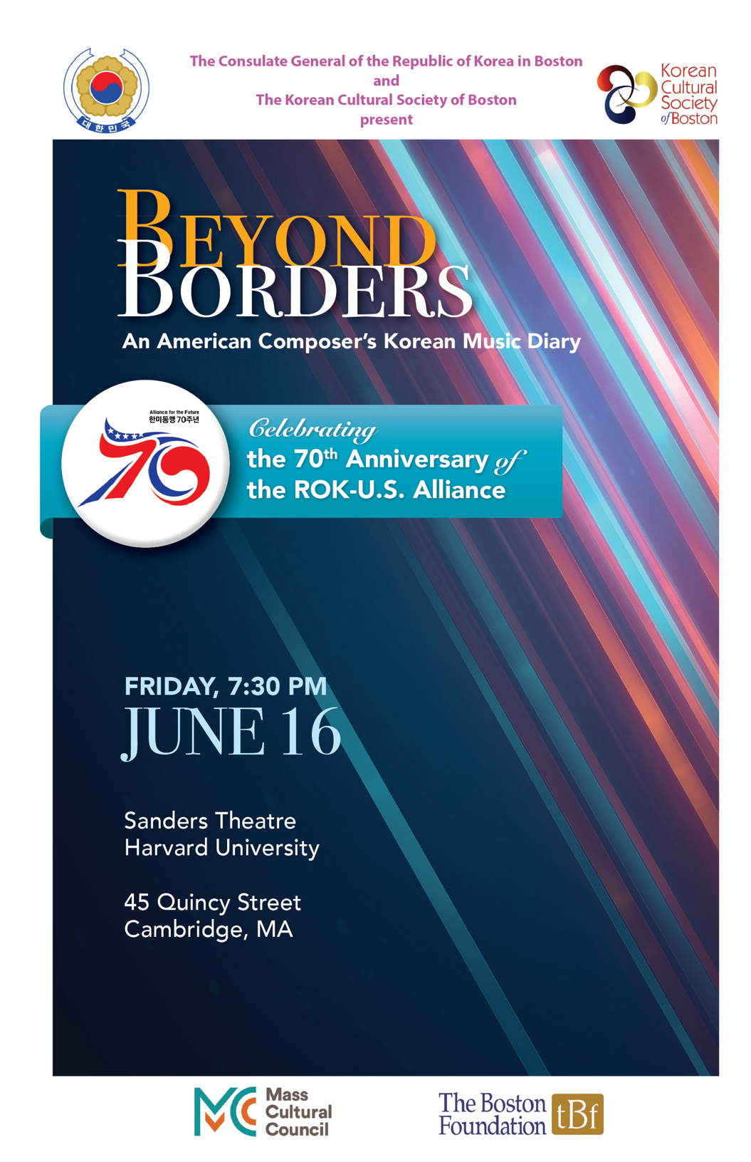

Beyond Borders:
An American Composer's Korean Music Diary
celebrating the 70th Anniversary of ROK-U.S. Alliance

Friday, June 16th at 7:30pm
Sanders Theatre
Harvard University

Hwangjonggung (황종궁)
Korean Traditional Court Music

Flute, Violin, Cello
Haegeum, Gayageum, Ajaeng, Janggu
with 5 Dancers

Sonata for Two Violins in e minor, Op. 3, No. 5
Jean-Marie Leclair (1697-1764)

Sooyun Kim, flute
Jae Cosmos Lee, violin

Haegum Solo with Janggu:
Jinyangjo of Ji Young-hui School Haegum Sanjo
지영희류 해금산조 중 진양조

Junghyeon Joo, haegum
Ji-won Bang, janggu

Ajaeng Solo with Janggu:
Jungmori & Jungjungmori of Yun Yun Seok School Ajaeng Sanjo
윤윤석류 아쟁산조 중 중모리, 중중모리

Yoona Kim, ajaeng
Ji-won Bang, janggu

Sonata for Violin and Cello Maurice Ravel (1875-1837)
Allegro
Très vif
Lent
Vif, acec entrain

Jae Cosmos Lee, violin
Jacques Wood, cello

--- Intermission ---

“Korean Influence”

Gayageum Solo with Janggu:
Jajinmori & Hwimori of Choi Ok Sam School Gayageum Sanjo
최옥삼류 가야금산조 중 자진모리, 휘모리

Hyunchae Kim, gayageum
Ji-won Bang, janggu

Seongeum 성음 for Solo Violin Richard Carrick (1971-)

Jae Cosmos Lee, violin
with dancers

Janggu Solo: Korean traditional Seoljanggo rhythm설장고
Ji-won Bang, janggu

Sandstone(s) 사암 Carrick
Flute, Violin, Cello
Haegeum, Gayageum, Ajaeng
with 5 Dancers

Conducted by Richard Carrick

ROK-US 70th Anniversary Alliance Music Celebration arr. by Carrick
Flute, Violin, Cello
Haegeum, Gayageum, Ajaeng, Janggu
with 5 Dancers

Conducted by Richard Carrick

Please turn off your cellphone and other electronic devices.
PROGRAM NOTES
Written by Annie Kim
Hwangjonggung (황종궁) – Korean Traditional Court Music
Korean traditional court music can be divided into three categories: a’ak (아악), dangak (당악) and hyangak (향악). The first two types, a’ak and dangak are derived from Chinese court music during the Zhou dynasty (1046-256 B.C.), while hyangak has its origins as a local Korean style. In particular, a’ak (“elegant music”) is closely associated with Confucian ideals and was revived by King Sejong, who sought to instill Neo-Confucian thought into Joseon society.^{i}
Hwangjonggung (황종궁) falls under this category of a’ak and is considered a Munmyo jereyak (문묘제례악), or ceremonial music performed at the Munmyo shrine in honor of Confucius. Hwangjonggung is one of 15 pieces played during this memorial ceremony. Today’s rendition will be performed by dancers accompanied by a combined ensemble of modern Western classical instruments (flute, violin, cello) and Korean traditional instruments (haegeum, gayageum, ajaeng, and janggu).
Leclair – Sonata for Two Violins in e minor, Op. 3, No. 5
Jean-Marie Leclair (1697-1764) is often credited as one of the leading figures who popularized violin performance in France during the 18th century. During his early career, Leclair had studied violin with Giovanni Battista Somis, a student of famed Italian composer and violinist Arcangelo Corelli. The influence of Somis and Corelli’s teachings can be seen in Leclair’s synthesis of both Italian and French styles of violin playing.
The Sonata for Two Violins in e minor, Op. 3, No. 5 is the penultimate sonata published in the Opus 3 set and is the only one in a minor key. It begins with the elegant “Allegro ma poco,” which features an intricate dialogue between the two instruments as they echo one another and interweave contrapuntal melodies. In the second movement, “Gavotte. Andante grazioso,” the interplay between the two parts is less dialogical and reciprocal, as the first violin takes the lyrical, somewhat simple melody while the second violin provides a consistent, eighth-note arpeggiated bass accompaniment. Finally, in the “Presto,” both parts play lively sixteenth-note passages to create a sense of constant movement, showcasing their virtuosic energy and intimacy.
Haegeum Solo: Jinyangjo of Ji Young-hui School Haegeum Sanjo – 지영희류
해금산조 중 진양조
Sanjo (산조), in contrast to Korean traditional court music, is a folk musical style that translates to “scattered melodies.” It involves a virtuosic, improvised solo, originally for the gayageum, with a drumming accompaniment on the janggu (a double-sided hourglass drum). A sanjo typically begins with the jinyangjo (진양조) rhythm, which is the slowest rhythm in sanjo and often accompanies lyrical passages. As the solo progresses, the rhythm gradually becomes faster, moving through jungmori, jungjungmori, gutgeori (occasionally), jajinmori, and hwimori rhythms.
The solo performed here is on the haegeum, which is a bowed string instrument comprised of a hollow wooden box, a rodlike neck, and two silk strings that extend from the body to the top of the neck. The style of playing is of the Ji Young-Hui (1909-1980) school, which is characterized by its use of shamanic melodies (sinawi) from Kyunggi Province.^{ii} Sanjo has traditionally been passed from teacher to student through aural transmission, and various schools—such as the Ji Young-Hui style—have developed from its leading performers.
Ajaeng Solo: Jungmori & Jungjungmori of Yun Yun Seok School Ajaeng
Sanjo – 윤윤석류 아쟁산조 중 중모리, 중중모리
The ajaeng (아쟁) is a bowed string instrument that consists of strings made of twisted silk fibers. In court orchestral music, the daeajaeng (larger, 7-stringed) is used, while in folk and solo performances, the soajaeng (smaller, 8-stringed) is used.
In this performance, we will hear the medium-tempo jungmori (중모리) and faster-paced jungjungmori (중중모리) rhythms played in the style of Yun Yun-Seok. Yun Yun-Seok (1939) studied gayageum with his father, and eventually began playing Korean traditional music after enrolling in the National Gugak Center. He is particularly known for establishing a free, improvisatory style of playing on the ajaeng.^{iii} Interestingly, unlike other instrumental schools, ajaeng sanjo schools derive their names from the pupils rather than the teachers, with these students adding their own characteristics to transform the style they were taught. Yun Yun-Seok, who largely improvised upon melodies (rather than playing them in their original form), was one of the foremost innovators for ajaeng sanjo.^{iv}
Ravel – Sonata for Violin and Cello
Maurice Ravel (1875-1937) dedicated the Sonata for Violin and Cello to Claude Debussy, which he contributed to La Revue musicale in commemoration of the hugely influential composer. In line with Debussy’s own musical aesthetics and styles of his late period, the sonata foregrounds melody over harmonies, with Ravel marking that this minimalist approach to harmony marked a turning point in his compositional trajectory.
The sonata-form “Allegro” begins with the violin and cello playing a melody that alternates between major/minor, and they do so in the same register, creating an intimate and unique interplay between the airy timbres of the cello’s upper register and the more full-bodied tone of the violin’s middle register. As the movement progresses and gains urgency, the cello descends into its lower register as the violin ascends, creating a rich sound that eventually settles, ending with both instruments playing harmonics.
“Très vif” features pizzicato interspersed with some bowed phrases in both instruments, and the movement’s melodies and rhythms are reminiscent of folk (and perhaps even jazz) styles. The juxtaposition of plucked and bowed sounds is further emphasized by the variety of colors/timbres called for throughout the movement, including some passages played sul ponticello (on the bridge) towards the end of the movement.
“Lent” begins with a solemn, contemplative melody in the cello that is then taken up by the violin. There are whispers of pentatonic and blues scales throughout these melodies, and the climax of the movement is characterized by great intensity and dissonance that slowly dissipates through the end of the movement. Meanwhile, “Vif, avec entrain” is an energetic and rhythmically-driven finale that showcases the many textures, timbres, and colors from the previous movements. Like the second movement, there are clear nods to folk musical styles within the phrases, and these motifs are fragmented, developed, and spun out. The movement, which was largely dissonant, concludes somewhat unexpectedly with both the violin and cello plucking a large, consonant C major chord.
Gayageum Solo: Jajinmori & Hwimori of Choi Ok Sam School Gayageum
Sanjo – 최옥삼류 가야금산조 중 자진모리, 휘모리
Of all the Korean traditional instruments, the gayageum is perhaps the most well-known. It is a plucked/strummed string instrument made of 12 twisted silk fiber strings, as well as 12 movable supporting bridges.
Choi Ok-Sam (1905-1956) was widely known for the range of emotions and colors in his playing—from delicate and rich, to piercing and almost metallic.^{v} His style of playing is especially known for drawing upon pansori (another folk genre consisting of vocal storytelling) and southern style rhythms.^{vi} This performance will feature the final two rhythms of the sanjo—jajinmori, and hwimori, which are the fastest rhythms and often accompany dramatic or urgent passages.^{vii}
Carrick – Seongeum 성음(2015) for solo violin
Seongeum is a solo violin piece, written for a collaboration with choreographer Miro Magloire for moving violinist and dancer, entitled Trust. The work was commissioned by Periapsis Music and Dance and was premiered by Lauren Cauley in February 2016 in Brooklyn, NYC.
This work asks the violinist to perform melodies in a vocalizing manner. The melodies and rhythms should be interpreted from a Pansori vocalist’s point of view—highly dramatic and lyrical. The main inspiration for this work is the Korean traditional Pansori singing style, seongeum, which includes highly ornamented and expressive vocal embellishments, where sounds, register, and dynamics often suddenly change from one moment to the next.
This score uses a mix of Korean instrumental embellishment techniques and Western techniques to help transcribe the Korean expressions and style to a western instrument.
The Pansori tradition is performed by a solo singer/storyteller who sings a lengthy Korean folktale story, accompanied by a Janggu (hourglass drum) performer. Unlike the subtle movement and simple theatrical elements used, the vocal style is vast in its techniques and expansive in its range, from high sustained laser beam falsetto to deep low vibrato and inventive metric articulation of the text.
I hear the violin as a similarly expressive instrument, where the sonic nuances of bow articulations and finger techniques (glissandi, trill, etc) are the primary sources of its expressivity, with notes a distant second. Therefore, I was interested in translating Pansori vocalizations to the violin.
The fourth section of this piece is a transcription of Chun Hyang Ga-Jajin Sarang ga, a popular Pansori love song.
(Written by Richard Carrick)

Janggu Solo – Korean traditional Seoljanggo rhythm (설장고)
Seoljanggo was a term originally given to the leading janggu player within a troupe. The seoljanggo would engage in a friendly contest with another seoljanggo (often from a different region), and the two janggu players would exchange virtuosic, improvised rhythms to showcase their creativity and skill.
Seoljanggo has since become a solo practice as popularized by Kim Hong-Jip, and it is typically performed towards the end of a Pangut performance.^{viii}
Seoljanggo are highly idiosyncratic to each player and region, and contemporary performances involve both percussive and choreographed movement/dancing elements.^{ix}
Sandstone (the rock) is created over long periods of time by sediment of sand. Yet, sandstones (sand in the shape of stones) are easily made on the beach, coming apart as quickly as they are made. There is a kinship in this duality of experience when working with these ancient Korean instruments and melodies, which I have had the great pleasure of engaging for the past few years.”
Sandstone(s) references Chun Hyang Ga-Jajin Sarang ga, Dan Ga-Sa Cheol Ga and Bangataryeong Gangsanje Simcheongga. This score uses a mix of Korean and Western instrumental embellishment techniques.

Sandstone(s) was commissioned by the 2017 Pacific Rim Festival and premiered on October 27, 2017 in Santa Cruz, California, by the Gugak Contemporary Orchestra of Seoul and the New York New Music Ensemble.
(Written by Richard Carrick)
Carrick – ROK-US 70th Anniversary Alliance Music Celebration
This arrangement is written in celebration of the 70th anniversary of the ROK and US Alliance.
Written for western and korean traditional instruments, this arrangement features three Korean traditional folk melodies alongside two American Blues songs. The Korean Melodies are Ganggangsullae, Jindo Arirang, and Gyeonggi Arirang, all popular Korean melodies, with growing popularity to others outside the Korean Penninsula. Ganggangsullae is a popular dance song that is sung by everyone in the room, while the two Arirangs are popular songs from different regions of Korea with lyrics that embody the korean identity.
When choosing which American songs to represent its musical tradition, it seems the American blues tradition has deep historical significance, is well know around the world, and has some nice commonalities with Korean folk music. Sweet Home Chicago is by the Delta blues musician Robert Johnson and sings of a longing to return to a homeland, similar in spirit to some Arirang lyrics. That’s All Right, written by blues musician Arthur Crudup was later recorded by Elvis, which was then widely heard by the men and women of South Korea after the armistice.
Two musical traditions are combined in this arrangement, with western instruments playing Korean melodic embellishments and rhythmical patterns, while korean instrumentalists incorporate blues grooves and guitar pitch bending techniques. The score includes texts such as “Blues Shuffle with Semachi” (Semachi is a popular Korean rhythmic pattern), and both traditions are further unified by a long tradition of improvisation.
(Written by Richard Carrick)
----------------------------
Annie Kim is a PhD student in the Musicology & Ethnomusicology program at Brown University. Her research lies at the intersections of voice, sound, and performance studies, and some of her current areas of interest include minoritarian performances, technological mediation, timbre, temporality, and utopia.
----------------------------
References
^{i} Byeon Gyewon, “Intertwining Influences on the Musical Achievements of 15th Century Korea,” The Review of Korean Studies 25, no. 2 (Dec. 2022): 216.
^{ii} Lee Hyun-Sin, “Comparative Study on Ji, younghee style Haegeum Sanjo: Focus on Scores of 해금산조연구 and 뿌리깊은나무 산조전집,” 목원대학교 대학원 (2015).
^{iii} Park Sun-Hye, “윤윤석류 아쟁 산조 분석 -중모리・중중모리・자진모리에 기하여,” 용인대학교 예술 대학원 (2002), 9.
^{iv} Kim Yong-Ho, “산조아쟁의 발생과정과 아쟁산조의 유파 연구,” Yenungnam University (2009).
^{v} Gugak Broadcasting, https://www.igbf.kr/gugak_web/?sub_num=1004&searchYear=2016&searchMonth=3.
^{vi} Quan Dahui, “최옥삼류 가야금 산조 中 자진모리 선율에 관한 연구,” Chonnam National University Graduate School (2006).
^{vii} Gugak Archive, http://archive.gugak.go.kr/portal/main.
^{viii} Encyclopedia of Korean Culture, https://encykorea.aks.ac.kr/Article/E0029080.
^{ix} Park Eun Ha, “The Study on Dance Performance of the Seoljanggu: focused on the style of Yang Do Il in Chunchong Province,” The Korean Journal of Dance Studies 8, no. 8 (2001): 139-161.

ABOUT THE ARTISTS
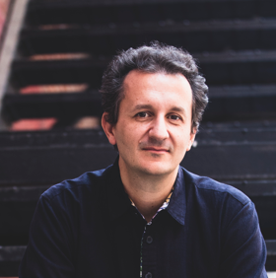
Richard Carrick (b. 1971, Paris, France) is a musician of wide-ranging vocations and proclivities, whose calling spans composition, performance, conducting, teaching artistry, education, lecturing, ensemble leadership, and curation. His reputation as an international leader in contemporary music rests on his tireless curiosity, intercontinental body of experience, and ceaseless exploration across disparate musical fields. His music is characterized by spatial depth and robust stasis; continual development and the evocation of profound human experiences.
Described both as "charming, with exoticism and sheer infectiousness" and "organic and restless" by The New York Times, Carrick's music is influenced by his multicultural background and experiences as well as his commitment to inspire professionals, audiences and youth through composition and live performance. His music spans beyond solo, chamber and orchestral compositions to include conceived works incorporating dance, graphic scores, multiple video projections, and group and conducted improvisation.
Carrick’s music has been programmed and presented internationally at festivals including NYPHIL BIENNIAL, ISCM World Music Days-Switzerland, Library of Congress, Enescu Festival, Pacific Rim Festival, Miller Theatre, Mid-American New Music Festival, and Darmstadt Summer Festival, and performed by musicians including the JACK Quartet, Mivos Quartet, Nieuw Ensemble, Wet Ink Ensemble, New York New Music Ensemble, Hyperion Ensemble, Sequitur Ensemble, Musica Nova, Hotel Elefant, Marilyn Nonken, Taka Kigawa, Margaret Lancaster, Vasko Dukovski, Jennifer Choi, Tony Arnold, Magnus Andersson, Steven Schick, Rohan de Saram, and others. Recent Concert Portraits were presented at Miller Theatre (NYC, 2019) and by New Chamber Ballet (2020) with whom he has written a number of new works for dance. He is the recipient of numerous awards, including a 2015-16 Guggenheim Fellowship in Music Composition and a 2011 Fromm Foundation Commission.
Carrick is co-founder and co-artistic director of the contemporary music ensemble Either/Or, declared 'first rate' and ‘a trustworthy purveyor of fresh sounds’ by The New York Times, and winner of the 2015 CMA/ASCAP Award for Adventurous Programming. As conductor and pianist, Carrick has worked closely with many celebrated composers including Helmut Lachenmann, Jonny Greenwood, Chaya Czernowin, Elliott Sharp, George Lewis, Anna Thorvaldsdottir, Iancu Dumitrescu, Robert Ashley, Karin Rehnqvist and Raphael Cendo. Carrick conducting E/O's ambitious performance of “John Cage Party Pieces” premiered 125 scores by renowned composers from around the world.
A teaching artist of considerable skill and experience, Carrick was instrumental in the development and expansion of the New York Philharmonic’s Very Young Composer program, in which he mentored hundreds of young composers to compose pieces to be performed by New York Philharmonic musicians (including pieces for full orchestra). His work in the program has expanded to include mentorship for young composers in Korea, Japan and the UK. As part of his work as a Guggenheim fellow, Carrick also founded a young composer program in both Israel and Kigali, Rwanda.
Carrick is the Chair of Composition at Berklee College of Music, where he directs the Neither/Nor Composer/Performer Ensemble, and teaches composing for dance and alternate approaches for structuring real-time music creation. He has presented masterclasses and lectures throughout the US, Canada, Holland, France, UK, Spain, Sweden, Germany, Israel, Rwanda, Japan and South Korea. Former posts include composition faculty at Columbia University and New York University.
His CD release, Cycles of Evolution, incorporates pieces commissioned and performed by Musicians of the New York Philharmonic, Either/Or, Sweden’s Ensemble Son, Hotel Elefant and String Orchestra of Brooklyn. Carrick conducts or performs on all works on this CD, which includes his 'apocalyptic' multimedia work for performers and video, Prisoner's Cinema. Carrick's first recording, also on New World Records, the “rich, beguiling” (The New York Times) extended chamber composition Flow Cycle for Strings, translates psychologist Mihaly Csikszentmihalyi's 'flow' principle into sonic terms. Carrick's improvisation-based disc Stone Guitars (New Focus Recordings) garnered critical attention in both the new music and guitar worlds, causing American Record Guide to note 'it may change your perception of electric guitar'.
A US/French citizen born in Paris of French-Algerian and British descent, Carrick received his BA from Columbia University, MA and PhD from the University of California-San Diego working with Brian Ferneyhough, and pursued further studies at IRCAM and the Koninklijk Conservatorium. Scores distributed by Project Schott New York.

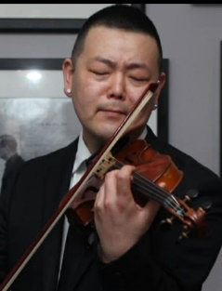
American violinist, Jae Cosmos Lee, who's performances have been acclaimed as "Delicate and beautiful" (Syracuse Post-Standard) and "Bursting with color" (Boston Globe), is Concertmaster of the Cape Symphony (Cape Cod, MA), and the Boston Festival Orchestra, co-founder of A Far Cry, the two-time Grammy nominated, self-conducted, democratically run chamber orchestra in Boston. He was also first violinist of the Pedroia String Quartet and is a podcast enthusiast, moonlighting as the writer & producer of the podcast, Beethoven Bad Boy. Jae has been a guest artist with the Audubon, Borromeo and Jupiterㄴ String Quartets, Pittsburgh New Music Ensemble, ECCO, Boston Musica Viva, Boston Modern Orchestra Project, Sound Impact, The Knights, the Firebird and Radius Ensembles, and has performed in concert halls throughout Europe, the United States, Canada and Asia. He is a recipient of numerous awards and honors, and has performed in many of the finest music festivals including Apple Hill, Aspen, Chautauqua, Norfolk, Sarasota, Vail, Banff, Seoul, Scotia, New South, Skaneateles, Salzburg, Ottawa, Prussia Cove and Kneisel Hall. Jae has worked closely with the members of the Cleveland, Juilliard, Takács and Tokyo String Quartets and holds degrees from the University of Michigan, Ann Arbor, the Cleveland Institute of Music, and the New England Conservatory. His performances have been heard widely on American Public Media's Performance Today, Boston's WGBH and New York's WQXR, along with public radio stations across Georgia, Maine, Minnesota & Vermont.

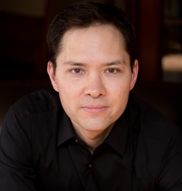
Boston-based cellist Jacques Lee Wood has performed around the world as a solo artist, chamber, and orchestral musician. His activities as a performer reflects a broad range of interests - historical performance on period instruments, commissioning new works for both modern and baroque cello, improvisation that incorporates live electronics, and composing his own material are just a few of the areas he explores in his creative scope. Dr. Wood is principal cello of the Cape Symphony and is a frequent guest artist with A Far Cry, Boston Baroque, Manchester Summer Chamber Music, House of Time, Yale Schola Cantorum, Trinity Baroque Orchestra, Bachsolisten Seoul, Bach Collegium Japan, Juilliard 415, and the Handel and Haydn Society. A recognized pedagogue, Wood is the cello professor at the University of New Hampshire and faculty at the Boston Youth Symphony Orchestra (Intensive Community Program, BEAM Program). Dr. Wood has received fellowships from the Norfolk Chamber Music Festival, the Yale Center for East Asian Studies for research at Sogang University (Seoul, South Korea), and the Yale School of Music for postdoctoral studies in early music with noted scholar and baroque violinist Robert Mealy. He is the founder and artistic director of the UNH Cello Festival and currently the cello faculty at the Summer Youth Music School (University of New Hampshire), Norfolk Chamber Music Festival, and Point Counterpoint. An active guest lecturer and clinician, Dr. Wood has presented on a broad range of topics ranging from historical performance practice for the modern musician to music technology in the pedagogical process. A grammy-nominated recording artist, Wood has released recordings on the Hyperion, Musica Omnia, and Navona labels. Dr. Wood completed his BM at the New England Conservatory of Music under Laurence Lesser, and holds a MM and DMA from Yale University, where he studied with Aldo Parisot.

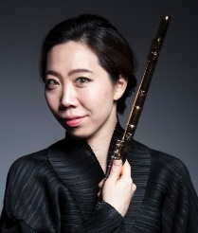
Praised as “a rare virtuoso of the flute” by Libération, Sooyun Kim has established herself as one of the rare flute soloists on the classical music scene. Since her concerto debut with the Seoul Philharmonic Orchestra, she has enjoyed a flourishing career performing with orchestras, including the Bavarian Radio Symphony, Munich Philharmonic, Munich Chamber Orchestra, and Boston Pops. She has been presented in recital in Budapest’s Liszt Hall, the Kennedy Center, Sibelius Academy in Helsinki, and Kobe’s Bunka Hall. Her European debut recital at the Louvre was streamed live on medici.tv. A winner of the Georg Solti Foundation Career Grant, she has received numerous international awards and prizes including the third prize at the ARD International Flute Competition. Her summer appearances include the Music@Menlo, Spoleto USA, Yellow Barn, Rockport, Olympic, Charlottesville, Ravinia, and Tanglewood festivals. Her special interest in interdisciplinary art has led her to collaborate with many artists, dancers, and museums around the world such as Sol Lewitt, the Isabella Stewart Gardner Museum, and Glassmuseet Ebeltoft in Denmark. An alum of Bowers Program (formerly CMS TWO), she is an Artist Member of the Chamber Music Society of Lincoln Center. she studied at the New England Conservatory under the tutelage of Paula Robison. She is currently on the faculty of the Longy School of Music of Bard College and teaches summer courses at Orford Musique. Kim plays a rare 18-karat gold flute specially made for her by Verne Q. Powell Flutes.

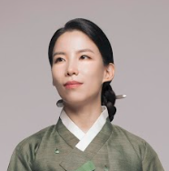
Born in Korea 1984, Hyunchae Kim spent her childhood in Jinju, a small city in the southern part of the country where she began to learn gayageum. She moved to Seoul at the age of fifteen and entered the National Gugak High School where she started her professional training as a musician.
Hyunchae Kim graduated from Seoul National University majoring in gayageum and finished her Masters and Doctorate degrees at Seoul National University, writing her dissertations on gayageum sanjo music. She won first prize in the traditional music competition held at the National Gugak Center in 2009 and the Presidential Prize in the Gurye Gayageum Competition in 2019. She has also been designated as Apprentice of Gayageum Sanjo & Byeongchang, National Intangile Cultural Asset.
Hyunchae Kim was a member of the Korean music ensemble Jeong Ga Ak Hoe for seven years, performing both the traditional and contemporary repertoire. She encountered Na Hyo-shin while working on one of her pieces for traditional Korean instruments, and she premiered six new gayageum pieces by Na since 2010. She has also played several pieces of the Belgium composer Baudouin de Jaer, performing at the Klara Festival in 2008, and releasing the album “Gayageum Sanjo Baudouin de Jaer” in 2013.
She recorded her first album “Kim Hyunchae Gayageum Sanjo : Choi Ok-sam Ryu” in 2010 and her second album "Hyunchae Kim Plays Music for Solo Kayageum by Hyo-shin Na" in 2021. After finishing her DMA, she published a book “History of Gayageum Sanjo Jinyanjo” analyzing more than twenty different gayageum sanjos recorded from the early to the late 20th century.
She taught gayageum at Seoul National University in 2017-2022 and a class in Korean music at Gachon University in 2016-2022. She is a member of the Society for the Preservation of the Choi Ok-sam school of Gayageum Sanjo, and a member of the Asia Zither Musicians' Association (AZMA). She has recently moved to United States for the artist in residence program at the Korean Performing Arts Institute of Chicago (KPAC).

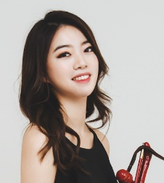
Jeonghyeon Joo is an award-winning haegeum performer, composer, improviser, and researcher who is an ardent advocate for new and experimental music. Joo draws narrative through an exploration of a somatic, corporeal relationship between instrument and body. She frequently composes about particular musical or sociocultural questions arising from her personal practice and training in haegeum performance.
As a unique experimental haegeum performer/composer, she has been selected as one of the Pioneering Artists of the Next Generation in Performing Arts by the Seoul Foundation for Arts and Culture (2022) for her work The Art of Bowing and by Arts Council Korea (2019-20) for her debut project EXERCISE. As an authentic Korean traditional musician, Joo has mastered classical and folk repertoires of Korean art music and won prestigious awards for her outstanding artistic achievements in haegeum including the Presidential Award of Korea (2012), First Prize at KBS Korean Music Competition (2014), Grand Prize (Award from Ministry of Culture, Sports and Tourism) at Jeonju-daesaseup Traditional Music Competition (2011), and Silver Prize at Dong-A Korean Music Competition (2012).
Recently, she has created large-scale performance projects with support from the Arts Council Korea and Seoul Foundation for Arts and Culture. Joo also has frequently given lectures and presented her works at notable conferences and institutions such as the International Computer Music Conference, New York City Electroacoustic Music Festival, Composition in Asia International Symposium, UCLA, UC Berkeley, UC Riverside, San Francisco State University, San Diego State University, Seoul National University, and Korean Cultural Center Los Angeles. She received a Master of Arts and Bachelor of Music from Seoul National University with a research focus on the development of contemporary études for the haegeum and is currently a DMA candidate at the California Institute of the Arts. She is on faculty at the California Institute of the Arts and Seoul Institute of the Arts, serving as a Program Director at CultureHub.

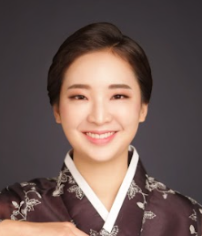
Yoona Kim is a versatile artist hailing from Seoul, South Korea, with exceptional skills in Ajaeng performance, composition, education, and improvisation. She holds a Bachelor's degree in Korean music Ajaeng performance and Musicology from Seoul National University, and a Master's degree in Contemporary Musical Arts from the New England Conservatory in Boston. Kim's artistic pursuits extend beyond music, as she has worked in a variety of mediums, including dance, art, soundscape, and theater. Her musical prowess has garnered recognition, including the Sin Ak Hoe Composition Competition award in 2017 for her work "Duet for Dae-Ajaeng and Female Jung-Ga vocal 'PyeonSuDaeYeop -Bloomless'," and the 1st prize in the InDongCho Korean Tradition Music Competition in 2018 for the Instrumental section.
Since 2016, Kim has been actively engaged as a player, composer, and artistic director of "Modern Gagok," a band that reimagines traditional Korean court music named Jung-Ak and traditional folk music for contemporary audiences. In 2017, Modern Gagok was selected as an artist of the month at JeongDong Theater's ChungChunManBal, and in 2018, the band was chosen as a New Wave Artist by the Surim Cultural Foundation, showcasing their work "Modern Sound." Modern Gagok has released three albums so far, including their first album "ModernGagok" in 2019, single "Ordinary Day" in 2020, and another single "Unlimited" most recently.
Kim's versatility as an artist has taken her on numerous international tours, performing in countries such as Germany, India, Vietnam, Switzerland, France, and Colombia. Currently, she is pursuing her Graduate Diploma in Contemporary Musical Arts at the New England Conservatory, where she has studied under renowned instructors such as Lautaro Mantilla, Anthony Coleman, Hankus Netsky, and Carla Kihlstedt.
Currently, Kim is an active performer in the improvised music scenes in Boston, Connecticut, and New York. She is a faculty member and assistant director of the Boston Academy of Korean Traditional Arts in Boston. She is also a member of the free improvisation trio with Grant Beale and Sam Childs, a member of the Zither Trio Paulownia, and a member of Berklee Global String Band. Kim is passionate about expanding her artistic horizons through her ongoing studies and performances.

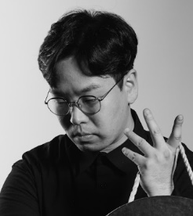
Ji-won Bang is a percussionist, composer, and writer from Gyeongju, South Korea. He is a member of Cultural Properties of South Korea's East Coast region and works as a musician for a shaman organization (Donghaean Byeolsingut). He received bachelor's degree in Korean music and percussion from Seoul National University.
His musical training started early and he had great interests in shamanic music. In order to find the original form of tradition, he visited the shamanic organization and learned shamanic art in which oral literature, folk tales, songs, dances, ideas, religion, music, and art coexist for a long time.
Based on them, he has created a team called "Bang Wool Sung" in 2019 and has been making works by adopting Korean composition methods. He also contributes to the flow of traditional music by creating various Sanjo (Korean traditional instrumental solo).
In 2021, he was selected Surim New Wave artist, played and directed a work called "Mujo巫祖: From Circulation," and in 2022, he was music director of the East Coast shamanic music of the Seoul Youth Gugak Band's ‘Best Lineup’.
He also played and directed "East Sea東海: Sea of Gods" at the National Intangible Heritage Center's certified trainee festival.
He has been focusing on the power of human voices and the special value of the instruments by using traditional minimalist materials. He believes that the mediating nature of the instrument connects the material and the soul, and that one of the important roles of the arts activities is praying to the invisible beings.

New Chamber Ballet
New Chamber Ballet believes that small is beautiful and expressive. For over 18 years, the company has been redefining the way audiences experience contemporary ballet and chamber music: performing it up-close and in-the-round in nontraditional venues. The magic of live performance, rekindled in an intimate setting without theatrical lights or curtains, reveals a profound sense of humanity and deepens the connection between artists and audience.
Praised by The New York Times as “one of the small-scale delights of the New York Dance Scene,” the company is noted for its groundbreaking collaborations with composers and musicians in choreographies by founder Miro Magloire.
Recently the company has created site-specific works engaging architecture ranging from Bramante’s Renaissance-Tempietto in Rome to Tadao Ando’s Clark Museum and a new building by Pritzker Prize winners SANAA.
The company has performed nationally from California to Connecticut, and internationally from Germany to Guatemala. But its artistic home remains its ongoing series in New York City. “In a city full of ballet, Magloire’s New Chamber Ballet is a welcome and unique voice… Indeed, with music and choreography that remind us of our own humanity, Magloire, with New Chamber Ballet, will continue to show us what is possible for ballet.” (Tara Lindis, Times Square Chronicle)

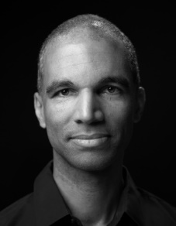
Miro Magloire, the founder and Artistic Director of New Chamber Ballet, has created over one hundred ballets in his signature sculptural style. Magloire and his company have broken many boundaries in classical dance, from using an in-the-round presentation for all performances, to fielding its singular, all-female company of long-legged, virtuosic dancers.
As former New York Times dance critic Alastair Macaulay wrote, "It's heartening to see work so focused on the meeting of dance and music,” lauding Miro as “refreshingly original,” in work that former New York Post dance critic Leigh Witchel called “bracing, daring, and calmly radical.”
Trained as a composer as well as a choreographer, Magloire is known for his ground-breaking collaborations with musicians and special affinity for cutting-edge contemporary music, as well as for the no-frills, unaffected aesthetic he has pioneered with his company.
Recent commissions include works for the New York Choreographic Institute, the American Academy in Rome, and the Sarasota Opera among others. In 2017 he was one of 25 arts leaders nationally selected for the Association of Performing Arts Presenters (APAP) Leadership Fellows Program.
Magloire’s works have also been commissioned by Joyce/SoHo, Roulette, the Moving Sounds and Sonic Music Festivals in NYC, the Sarasota Opera, and the Center for Faith and Work NYC, and performed at the Jacob's Pillow Inside/Out Stage, Ailey/Citigroup Theater, the Center for Performance Research, the Clark Institute, and Bramante's Tempietto at San Pietro in Montorio in Rome, among other venues. He has collaborated with the Argento Chamber Ensemble, the Momenta String Quartet, Ensemble Moto Perpetuo and Ensemble Sospeso, and the vocal ensembles Ekmeles, Variant 6, and AuditivVokal.
Born in Munich, Germany, Magloire studied composition with Mauricio Kagel at the Cologne Conservatory of Music before settling in New York City. The recipient of several O'Donnell-Green Music and Dance Foundation Grants, he was profiled in a 2008 full-page article in the Sunday NY Times. He was a guest speaker at the Massachusetts Institute of Technology’s MIT Media Lab in 2022.
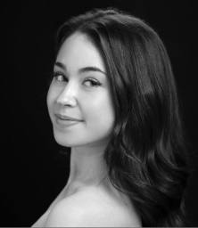
Anabel Alpert has been a principal dancer with New Chamber Ballet since 2018, appearing in lead roles in numerous ballets and dance films by Miro Magloire. Prior to joining the company, she was a member of the Sarasota Ballet, Ballet Austin, and the American Contemporary Ballet in Los Angeles, performing featured roles in works by George Balanchine, Sir Frederick Ashton, and Matthew Neenan among others. This past winter, she has appeared as a guest principal in Nutcracker productions of the Lake Tahoe Dance Collective and the Philadelphia Youth Ballet.
Ms. Alpert started her early dance training in South Florida with Boca Ballet Theatre, and went on to graduate from Miami City Ballet's Pre-Professional Program.

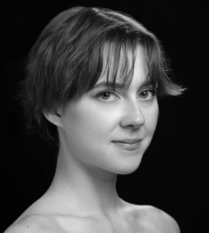
Nicole McGinnis joined New Chamber Ballet in 2021 as a principal dancer, and has since originated roles in four ballets by Miro Magloire. After training in Pasadena, California, and at the Marat Daukayev School of Ballet in Los Angeles, Ms. McGinnis joined the Graduate Program at Pittsburgh Ballet Theatre, where she had the opportunity to perform with the Pittsburg Ballet Theater in works by George Balanchine and Terrence Orr.

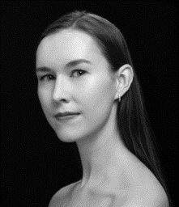
Megan Foley has been a principal dancer with New Chamber Ballet since 2018, featuring in five full-length ballets and several revivals by Miro Magloire. Ms. Foley was also a member of the Oklahoma City Ballet Studio Company and the New York Dance Project, where she performed in works by George Balanchine, Kenneth MacMillan, Gerald Arpino, Helgi Tomasson, and Robert Mills. Ms. Foley received her training at the International Ballet School in Colorado and the San Francisco Ballet School.

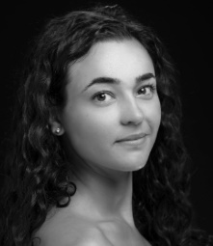
Rachele Perla has been a principal dancer with New Chamber Ballet since 2017. Since joining the company, she has originated countless roles in ballets by Miro Magloire and Richard Isaac. A native of West Boylston, MA, Ms. Perla received her early dance training at the Boston Ballet School before earning her BFA in Dance at Fordham University/The Ailey School. She has performed works by George Balanchine, Mikko Nissinen, Alvin Ailey, Adam Barruch, Amy Hall Garner, and Robert Hill.

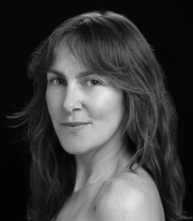
Amber Neff has been a principal dancer of New Chamber ballet for twelve years, during which she originated several dozen roles in works by Miro Magloire, Gabrielle Lamb, and Constantine Baecher. This winter, her appearances with New Chamber Ballet were honored as "Standout Performances of the Year 2022" by the leading American ballet publication, Pointe Magazine. Ms. Neff has danced with the Suzanne Farrell Ballet, Boston Ballet, Richmond Ballet, the Eglevsky Ballet, Emery LeCrone DANCE, and Claudia Schreier and Company, and the Intermezzo Dance Company.

Ms. Neff began her training in New York at the Dance Design School, where she completed the RAD vocational examinations. She went on to train at the HARID Conservatory in Florida on full scholarship, and later graduated from the the Jacqueline Kennedy Onassis School at American Ballet Theater in New York.

Future Events of Korean Cultural Society of Boston

June 17 – July 1 Namhi Kim Wagner Memorial Exhibition
Nye Gallery, LexArt
130 Waltham St, Lexington, MA
August 6, 3:00 pm Inmo Yang Violin Recital with Janice Lu
New England Conservatory’s Williams Hall
290 Huntington Ave, Boston, MA
Sept. 30, 7:30 pm Piano Extragavanza: Three Generations of
Pianists
New England Conservatory’s Jordan Hall
290 Huntington Ave, Boston, MA
Oct. 7 – 21 Hanji (Korean Paper) Exhibition
Nye Gallery, LexArt
130 Waltham St, Lexington, MA

