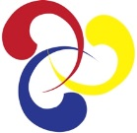
Korean Cultural Society of Boston
www.kcsBoston.org

KOREAN CULTURAL SOCIETY OF BOSTON presents
Korean-American Contemporary Artists
at the Lexington Arts & Craft Society
130 Waltham St., Lexington, MA 02421

Korean Cultural Society of Boston (KCSB) presents an exhibition by Korean-American contemporary artists in the Boston area. Close to 30 art pieces, selected by Jane Portal, the Matsutaro Shoriki Chair, Art of Asia, Oceania, and Africa of MFA Boston, will be exhibited.
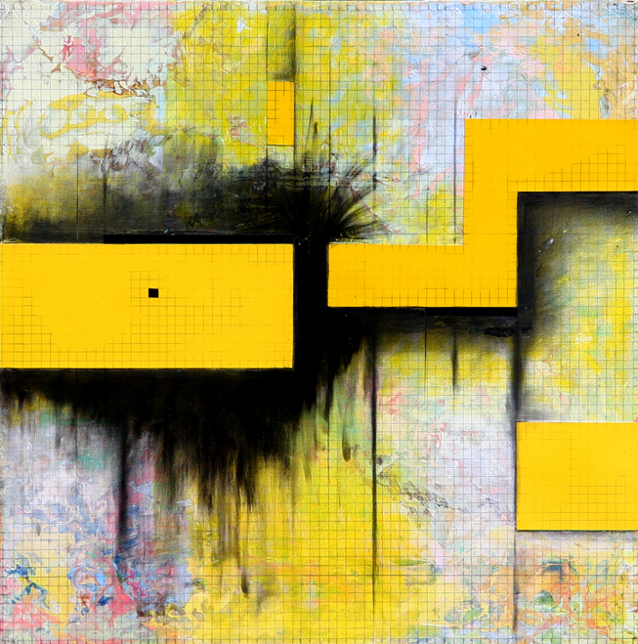
Besides ceramics pieces by invited artists Youngjae Lee and Namhee Kim, the exhibition features pieces in a variety of media, including oil paint, conte crayon, clay, fabric, and video. The first art exhibition by KCSB runs from Oct. 5th to 19th at the Lexington Arts and Craft Society (130 Waltham St. Lexington, MA 02421). A reception will be held from 2-4 pm on Oct. 5.
KCSB was founded last year to focus on presenting Korean culture. An exciting concert of Korean Traditional music and dances was organized last winter. Besides the exhibition, KCSB organizes a classical music concert by acclaimed Korean-American musicians on Dec. 6 at the Jordan Hall in the New England Conservatory.

