Korean Cultural Society of Boston

2022-2023 season
For immediate release
May 12, 2023
ay 12, 2023

The Korean Consulate General of Boston and the Korean Cultural Society of Boston co-present “Beyond Borders: An American Composer’s Korean Music Diary”
On June 16 at 7:30 PM at Harvard University’s Sanders Theatre
In honor of the 70th Anniversary of ROK-U.S. Alliance, this concert is a celebration of the close bond between South Korea and the United States. This special presentation highlights cross-cultural collaborations through the universal languages of music and dance. Traditional Korean Music (Gugak) instrumentalists, Western classical and contemporary musicians, and the New Chamber Ballet will all share the same stage, and the concert will feature exceptional soloists from both the U.S. and Korea.

The program includes compositions by Ravel, Leclair, traditional Korean Sanjo and court music, and works by composer/conductor Dr. Richard Carrick from the Berklee College of Music. Dr. Carrick, who studied Gugak in Seoul, will also present special arrangements of Delta Blues, early Rock ‘n’Roll, Arirang, and more. The photos and bios of the performers can be found here.

PROGRAM

- Hwangjonggung, traditional Korean Court Music
- Sonata in e minor, Op. 3 No. 5 for flute and violin by Jean-Marie Leclair
- Haegeum solo with Janggu
- Ajaeng solo with Janggu
- Sonata for Violin and Cello by Maurice Ravel

"Korean influence"
- Gayageum solo with Janggu
- Seongeum for solo violin by Richard Carrick
- Janggu solo
- Sandstone(s) by Richard Carrick
- Korean and American Folk songs (arr. Carrick)

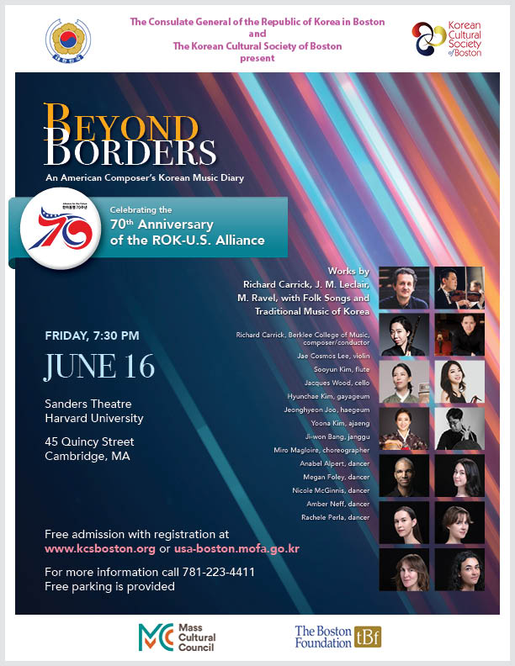

# # #

Free admission with registration at kcsboston.org or usa.boston.mofa.go.kr.

Contact
Dr. Yoo Sun Na, Chair of KCSB Music Committee, ysn.kcsb@gmail.com

